|  |  | **VOCABULARY - JOBS IN IT & TELECOMS** |  |
| --- | --- | --- | --- |

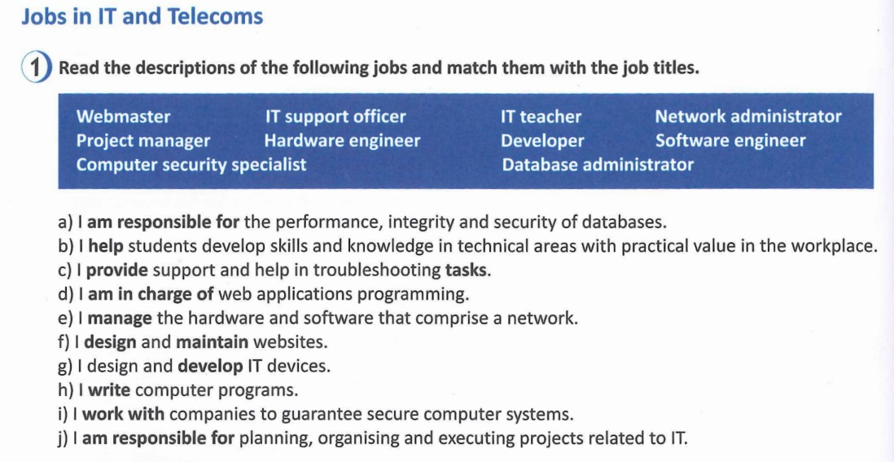

| **a)** |
| --- |
| **b)** |
| **c)** |
| **d)** |
| **e)** |
| **f)** |
| **g)** |
| **h)** |
| **i)** |
| **j)** |

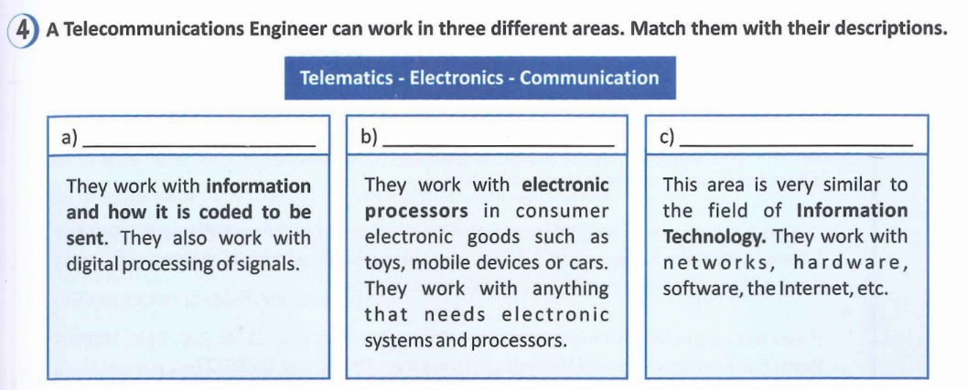

| **a)** | **b)** | **c)** |
| --- | --- | --- |

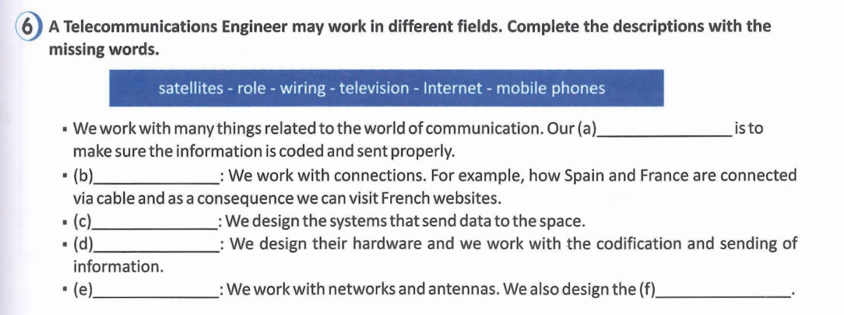

| **a)** |
| --- |
| **b)** |
| **c)** |
| **d)** |
| **e)** |

**READING - JOB ADVERTS**

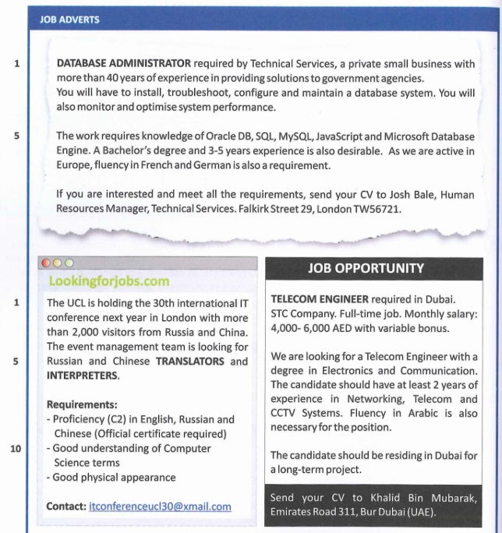

### Reading comprehension

**1) Match the words with their corresponding definitions. Then find them in the text.**

| **hold – troubleshoot – Bachelor – optimise – meet requirements** |
| --- |

a) To analyse or diagnose a problem to the point of finding the best solution

b) To make something as effective, perfect and useful as possible

c) To satisfy, to suit the skills and qualifications you are asked for

d) The lowest academic degree conferred by universities and colleges

e) To organise, to celebrate (a meeting)

**2) Read the job offers again and answer the following questions:**

a) In which position does the applicant need to be focused on problem solving? Why?

b) Which offer requires more communication skills? Why?

c) Is experience required in all the job positions?

d) In which job would you be living and working abroad?

**3) Are these statements true or false? Justify your answer.**

a) A university degree is required in all the jobs.

b) Mastering languages is a must if you want to apply for any of these jobs.

c) If you want to apply for the jobs you have to send your CV by post.

d) The looks are relevant when applying for one of the jobs.

e) The salary in one of the jobs is fixed.